PAPER TITLE ( 12PT TIMES NEW ROMAN, BOLD, LEFT ALIGNED)
Correspondence Author *¹, Co-author^{2…} (11pt Times New Roman, Left)
^{*1} Department, Collage, Country (11pt Times New Roman, Left)
² Department, Collage, Country (11pt Times New Roman, Left)
Keywords: 2-6 Keywords are required (10pt Times New Roman, Justified).

ABSTRACT
An abstract of no more than 200 words (10pt Times New Roman, Justified).

INTRODUCTION
All content should be written in English and should be in 1 column.
- Page type will be A4 with normal margin, word spacing should be 1.
- No space will be added before or after paragraph.
This section should be typed in character size 10pt Times New Roman, Justified.
MATERIALS AND METHODS
SUBHEADING
Subheading should be 10pt Times new Roman, justified.
This section should be typed in character size 10pt Times New Roman, Justified
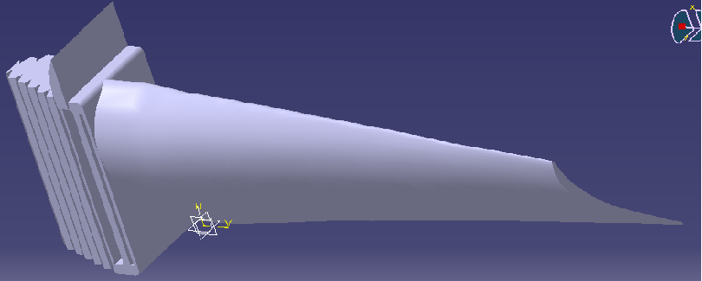
Fig 1 : 9pt Times New Roman, Center
SUB-SUBHEADING
Sub-subheading should be 10pt Times new roman, Italic, Justified.

RESULTS AND DISCUSSION
The results and discussion may be combined into a common section or obtainable separately. They may also be broken into subsets with short, revealing captions.
This section should be typed in character size 10pt Times New Roman, Justified

FORMULAE

R_{a}=R_{a}i_{a}+i_{a}$\frac{{di}_{a}}{dt }+M_{ab}\frac{{di}_{b} }{dt }+M_{ac }\frac{{di}_{c}}{dt}+a_{a}$ ₍₁₎

R_{b}=R_{b}i_{a}+i_{b}$\frac{{di}_{b}}{dt }+M_{ba}\frac{{di}_{a} }{dt }+M_{bc }\frac{{di}_{c}}{dt}+a_{b}$ ₍₂₎

R_{c}=R_{c}i_{c}+i_{c}$\frac{{di}_{c}}{dt }+M_{ca}\frac{{di}_{a} }{dt }+M_{cb }\frac{{di}_{b}}{dt}+a_{c}$ ₍₃₎

TABLES

Table 1: 9pt Times New Roman, Center.
MATERIAL | Max Stress  ( N/mm²) | Maximum Deformation, (mm) | Maximum Temperature, (^{O}C)
Titanium Al Alloy | Value | Value | Value
Nimonic 80 A Alloy | Value | Value | Value
Superalloy | Value | Value | Value

CONCLUSION
This fragment should obviously state the foremost conclusions of the exploration and give a coherent explanation of their significance and consequence.
This section should be typed in character size 10pt Times New Roman, Justified

ACKNOWLEDGEMENTS
This section should be typed in character size 10pt Times New Roman, Justified.

REFERENCES
- Gowreesh, S., Sreenivasalu Reddy, N. and Yogananda Murthy, NV. Convective Heat Transfer Analysis of a Aero Gas Turbine Blade Using Ansys, International Journal of Mechanics and Solids. 4, 2009, 39-46.
- B. Deepanraj, P. Lawrence, G. Sankaranarayanan, Theoretical analysis of gas turbine blade by Finite element method, Scientific World, Vol. 9, No. 9, July 2011, 29-33
- Gurrappa, I. V. S. Yashwanth, A. K. Gogia, The Behaviour of Superalloys in Marine Gas Turbine Engine Conditions, Journal of Surface Engineered Materials and Advanced Technology, 1, 2011, 144-149.
- Brooks CR. Heat treatment, structure and properties of nonferrous alloys. New York: ASM; 1984, 139–228.
- Huda Z. Development of heat-treatment process for a P/M superalloys for turbine blades. Mater 28(5), Des 2007; 1664–7.
- Boyce MP., The gas turbine handbook. 2nd ed. Houston, Texas: Gulf Professional Publishing; 2002, 411.

